Electrical Lighting Controls Schedule

Revision Date Description Created Checked
T1 2 Tender Issue
Schedule of Equipment – Single floor pluggable

Code | Description | iLight Series | Product Code | Image | Areas
LCM1 | Auto Addressing 10 Output Pluggable DALI LCM | iLight  Enterprise | LCMD-10 | 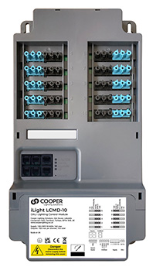 | Open Plan Office/ meeting rooms
P1 | Ceiling mount PIR/photocell 64mm cut out | iLight Enterprise | PPAD- C-DALI-ADDR | 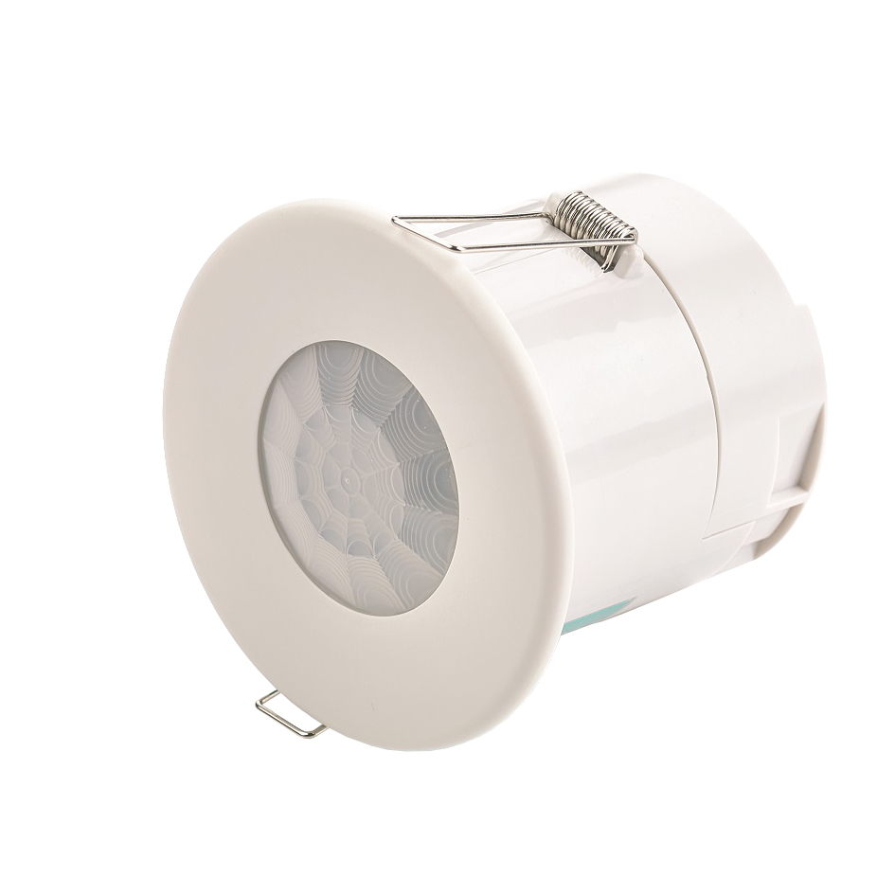 | Recess mounting
P2 | Analogue RJ12 connection, 49mm cut out for the iLight Enterprise  LCM | iLight Enterprise | AXCS01SRJ | 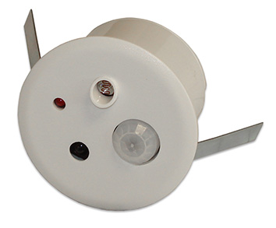 | Recess  mounting
P5 | HB DALI Ceiling mount PIR/photocell | iLight Enterprise | PPAD-C-HB-DALI-ADDR | 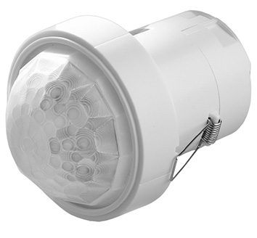 | High Bay - Atriums & Warehouses
CP2 | Metal Control Plate-  4 Button  Raise up/down | iLight Enterprise | Classic  Range | 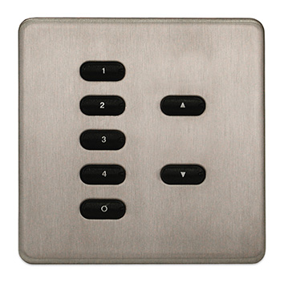 | Meeting rooms
CP3 | Plastic DALI Control Plate | iLight Enterprise | CLD Range | 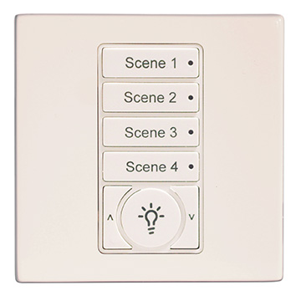 | Meeting rooms
TS1 | 8” Multiroom Colour Touchscreen | iLight Enterprise | TSE80 | 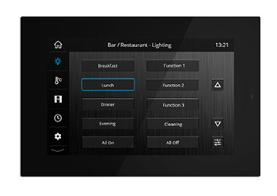 | Reception, meeting rooms or central controller
TS2 | 5.5” Multiroom Colour Touchscreen | iLight Enterprise | TSE55 | 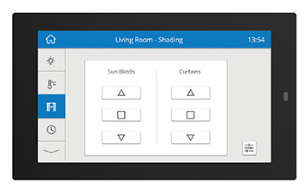 | Reception, meeting rooms or central controller
APP | iLight App  Lighting, HVAC, Shading | iLight Enterprise | TSEtouch | 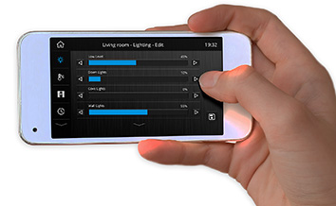 | Remote access/meeting rooms for end user applications
UI-2 | Mini Universal Interface  For Room Partition | iLight Enterprise | UIM | 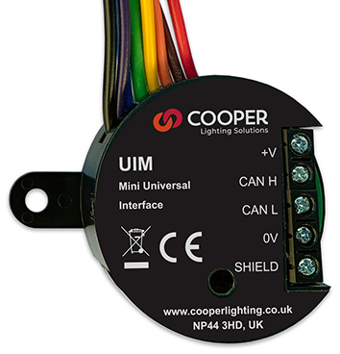 | Connection of switch contacts to CAN and room partition switches

