Electrical Lighting Controls Schedule

Revision Date Description Created Checked
T1 2 Tender Issue
Schedule of Equipment – Building wide multi-tenancy control equipment

Code | Description | iLight Series | Product Code | Image | Areas
CTRL1 | Backbone  Module | iLight  Enterprise | BN2-D | 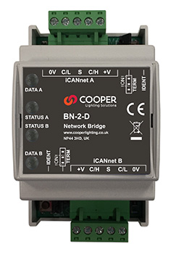 | Communications module for linking floors or zones
CTRL2 | TSE Interface, Schedular  Timed Events/Scene recall | iLight  Enterprise | TSI-1 | 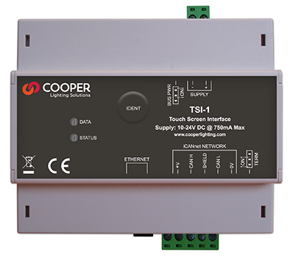 | Building wide control module
LCM1 | Auto Addressing 10 Output Pluggable DALI LCM | iLight  Enterprise | LCMD-10 | 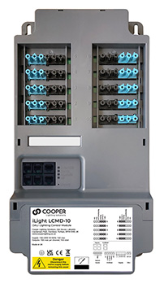 | Open plan office/meeting rooms
LCM2 | 2 Universe DALI Controller  (128 addresses) | iLight  Enterprise | SCMD2 | 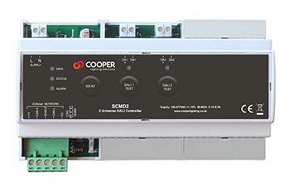 | Open plan office/meeting rooms
LCM3 | 4 Universe DALI Controller  (256 addresses) | iLight  Enterprise | SCMD4 | 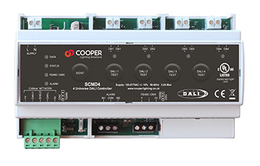 | Open plan office/meeting rooms
LCM4 | 4 x 32A Relay Module | iLight  Enterprise | SCMR0432 | 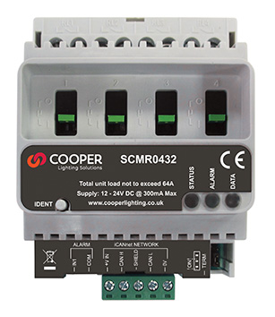 | For control of non-dimmable luminaires
LCM5 | 4 x 1 amp DALI to Phase Adaptive Dimmer  (leading / trailing edge) | iLight  Enterprise | SCMA0401 | 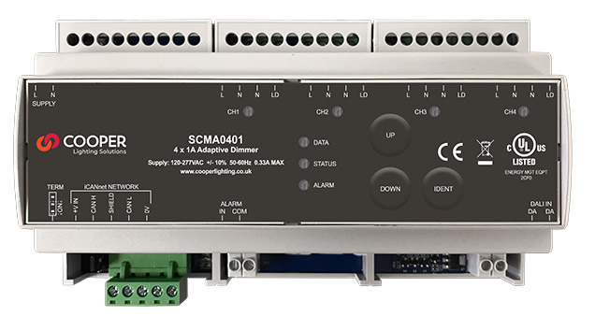 | For control of architectural mains driven luminaires
LCM6 | 12 x 32A Relay Module | iLight  Enterprise | SCMR1232 | 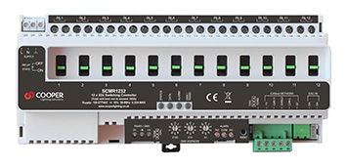 | For control of non-dimmable luminaires
LCM7 | 12 Digital Dimmer  Broadcast DALI / DSI / 1-10V | iLight  Enterprise | SCMH1200 | 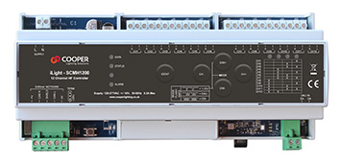 | Reception scene setting
LCM8 | Heating & cooling Controller | iLight Enterprise | HVAC-1 | 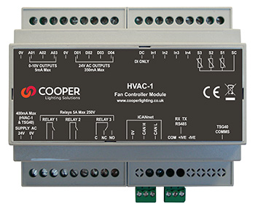 | Integrated into a fan coil controller
FD1 | DALI field relay  On of/off control | iLight Enterprise | FLTS | 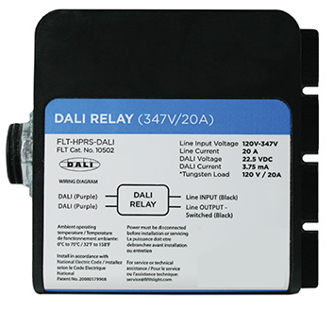 | For control of non-dimmable luminaires via DALI
P1 | Ceiling mount PIR/photocell 64mm cut out | iLight Enterprise | PPAD- C-DALI-ADDR | 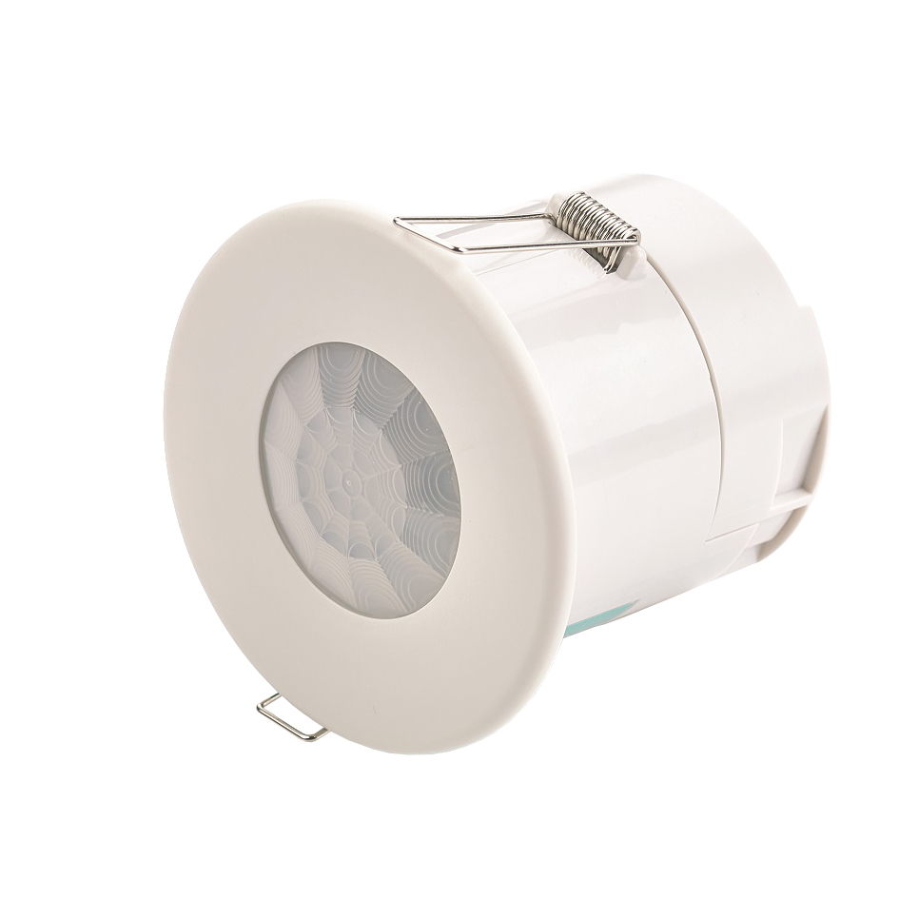 | Recess mounting
P2 | Miniature DALI PIR/Photocell 32mmcut out for integration into a luminaire | iLight Enterprise | PPAD- C-MB-DALI ADDR | 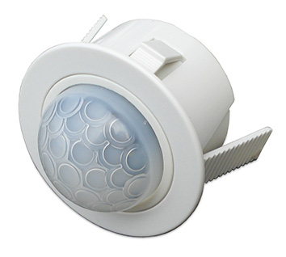 | Recess, Luminaire or Besa integrated
P3 | Analogue RJ12 connection, 49mm cut out for the iLight Enterprise  LCM | iLight Enterprise | AXCS01SRJ | 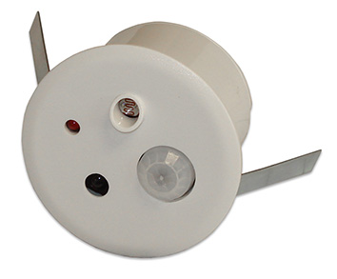 | Recess  mounting
P5 | HB DALI Ceiling mount PIR/photocell, 64mm | iLight Enterprise | PPAD-C-HB-DALI-ADDR | 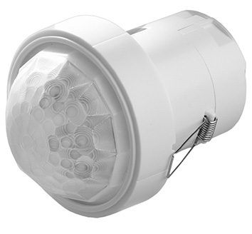 | High Bay - Atriums & Warehouses
CP1 | Metal Control Plate-  Configurable button sizes & engraving, | iLight Enterprise | Sencia  Range | 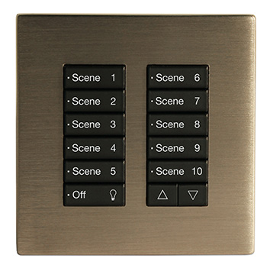 | Meeting rooms

CP2 | Metal Control Plate-  4 Button  Raise up/down | iLight Enterprise | Classic  Range | 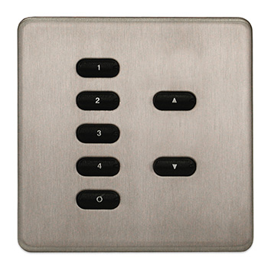 | Meeting rooms
CP3 | Plastic DALI Control Plate | iLight Enterprise | CLD Range | 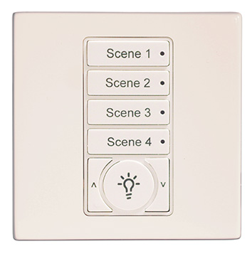 | Meeting rooms
TS1 | 8” Multiroom Colour Touchscreen | iLight Enterprise | TSE80 | 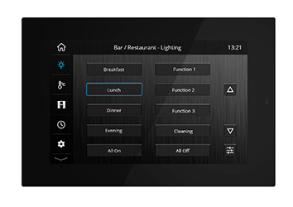 | Reception, meeting rooms or central controller
TS2 | 5.5” Multiroom Colour Touchscreen | iLight Enterprise | TSE55 | 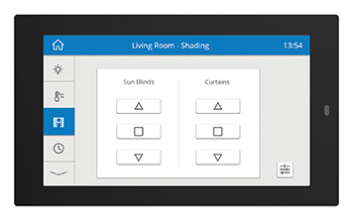 | Reception, meeting rooms or central controller
APP | iLight App  Lighting, HVAC, Shading | iLight Enterprise | TSEtouch | 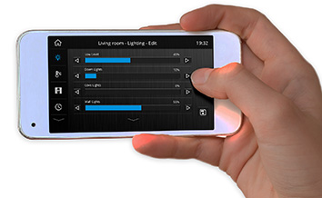 | Remote access/meeting rooms for end user applications
TS3 | 4” Colour Touch Screen for HVAC-1 Lighting, HVAC & Shading | iLight Enterprise | TSG40 | 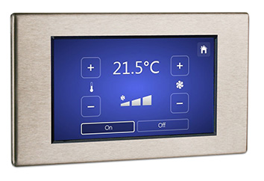 | Meeting rooms
UI-1 | DALI Input Unit | iLight Enterprise | DALI-I-U | 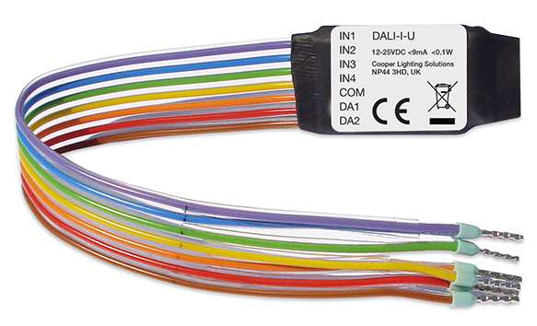 | Switch input module, via DALI
UI-2 | Mini Universal Interface | iLight Enterprise | UIM | 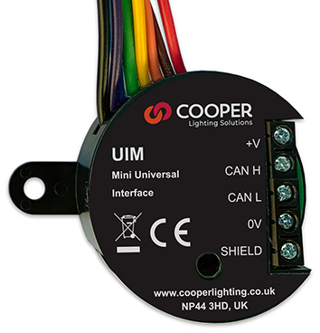 | Connection of switch contacts to CAN and for room partition switches
UI-3 | Universal Interface | iLight Enterprise | UIG-2 | 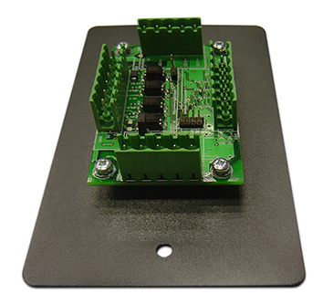 | For end user room partition dividing walls
Luminaire leads | 3,4,5, & 6 core leads | iLight  Enterprise / Solo | Various | 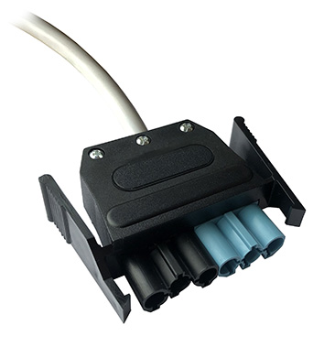
Luminaire  plugs | Standard & emergency | iLight  Enterprise / Solo | Standard  ACCPL-6P-01-B  Emergency  ACCPL-6P-01-R | 